Image Processing – HW01

309553048_多工所_陳柏丞

* Introduction：

Using techniques of contrast adjustment, noise reduction, color correction to enhance 6 images. As a result, you should write your processing techniques as modules so that you can try different combinations or parameters for different images.

* Methods：
  + Program Language：Python3.8
  + Image Processing：
    - Intensity Transform：
      1. Linear
      2. Log
      3. Gamma
      4. Piecewise-Linear
      5. Histogram equalization
    - Noise Filter：
      1. Mean Filter
      2. Median Filter
      3. Alpha-Trimmed-Mean Filter
      4. Bilateral Filter
* Results：

Image 1：

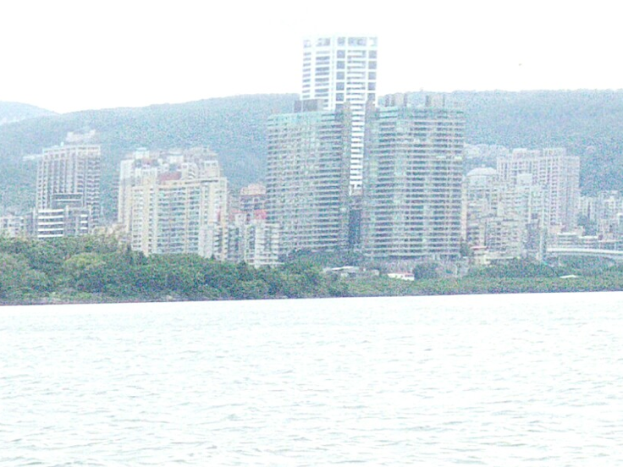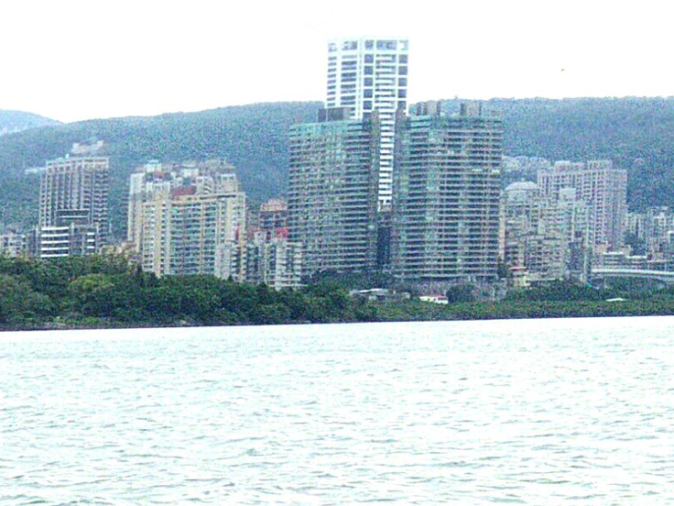

Origin Gamma = 1/2.2

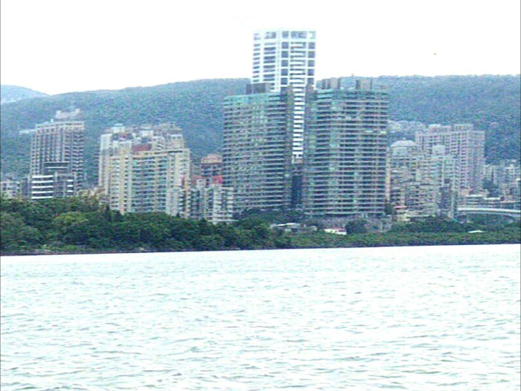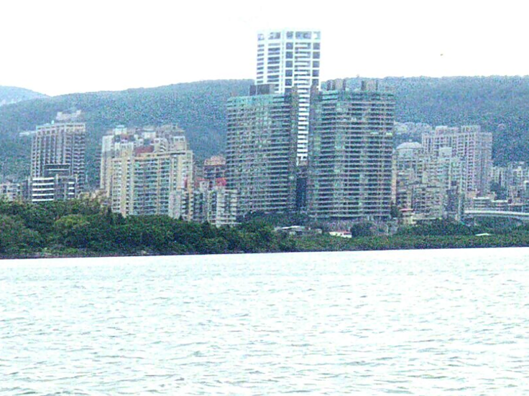

Gamma + Alpha-trimmed-Mean Gamma + Bilateral

Image 2：

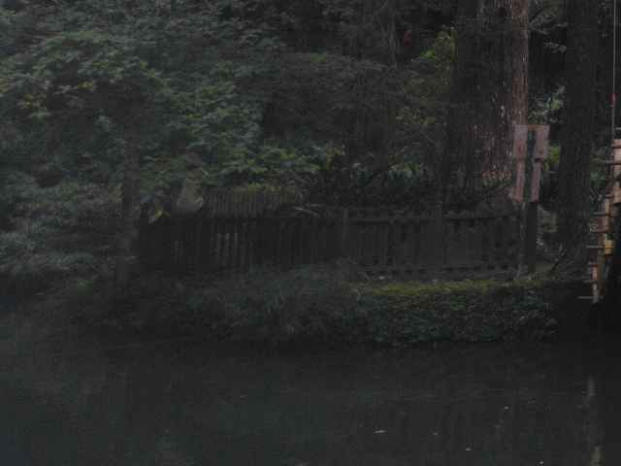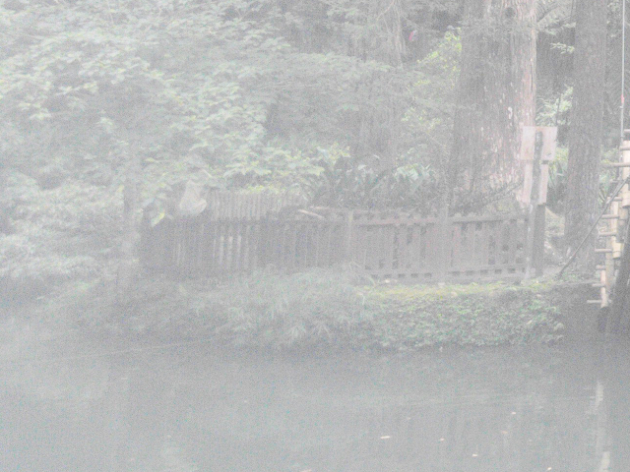

Origin Log

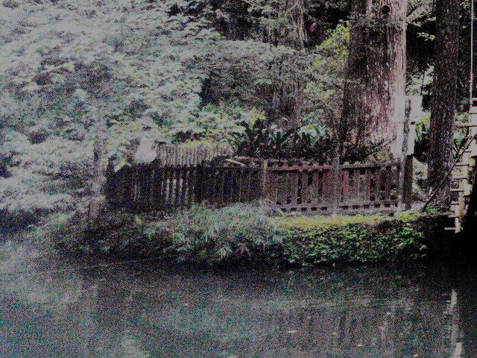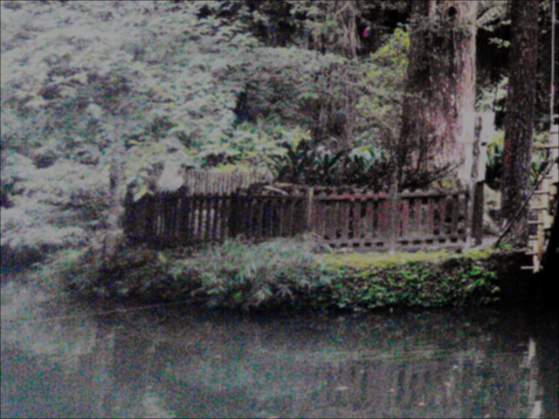

Histogram Equalization Histogram + Mean

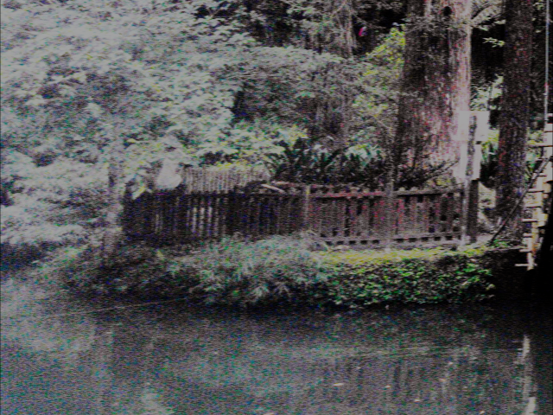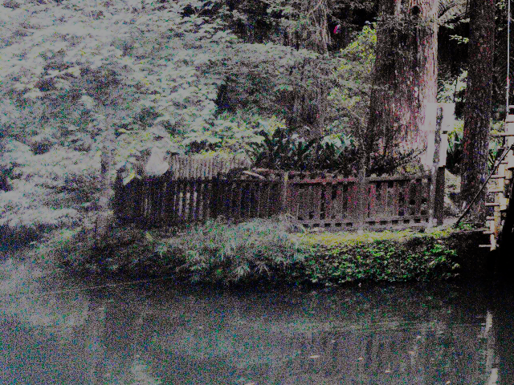

Histogram + Alpha-Trimmed-Mean Histogram + Bilateral

Image 3：

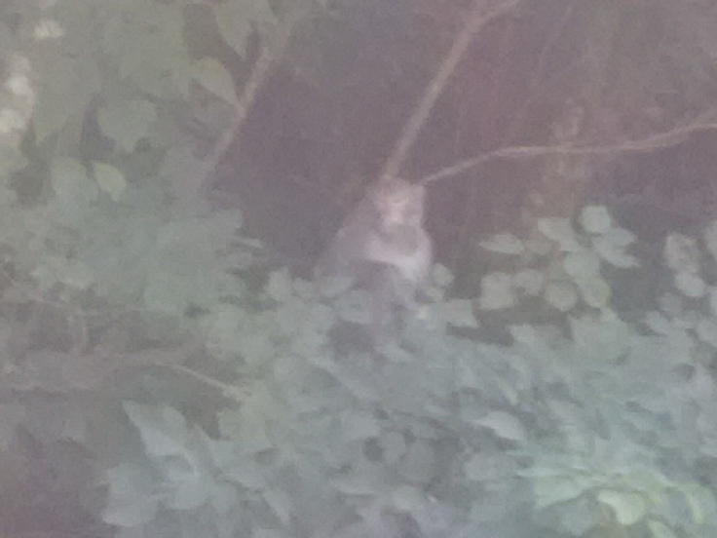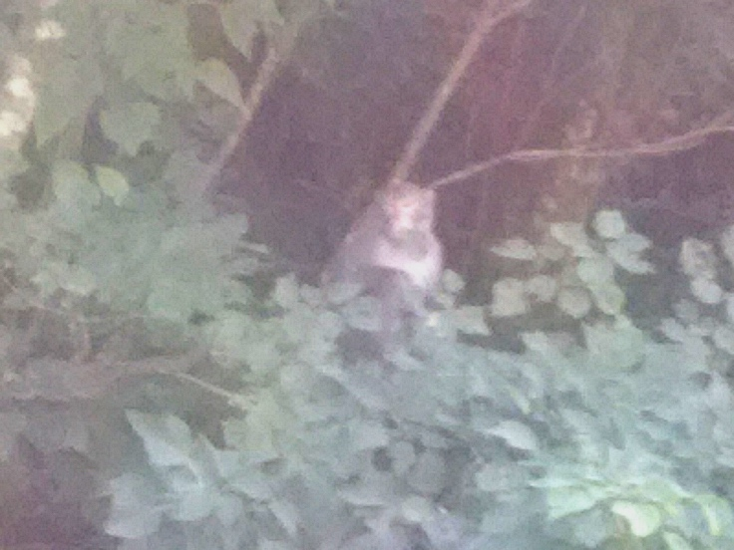

Origin Piecewise-Mean

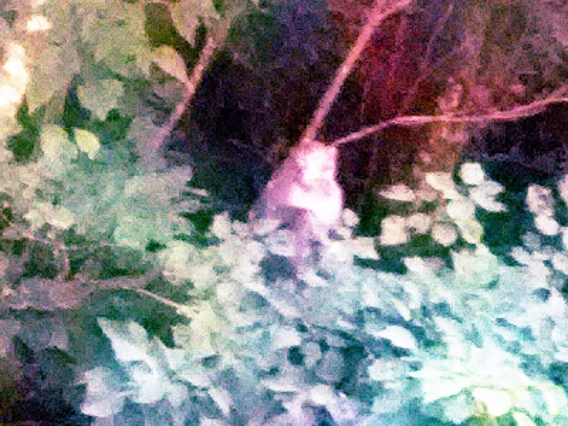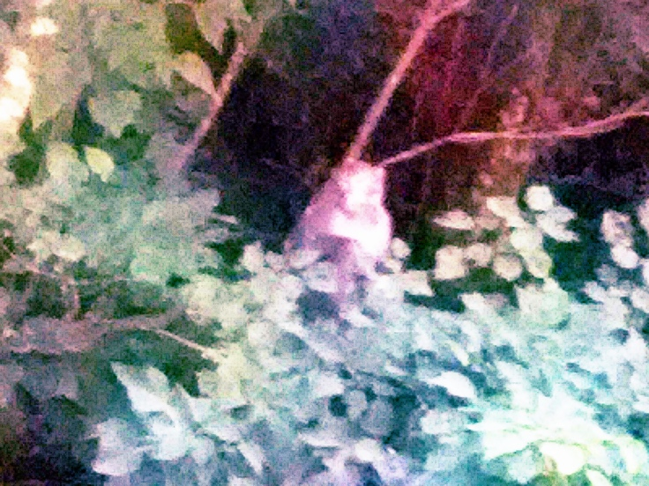

Histogram Equalization Histogram + Bilateral

Image 4：

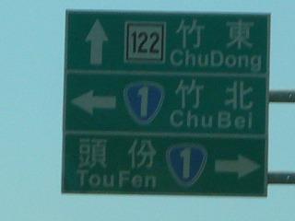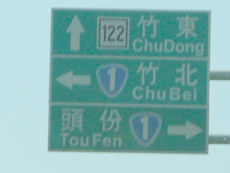

Origin Gamma = 2.2

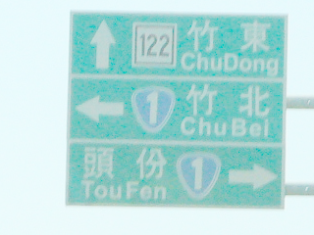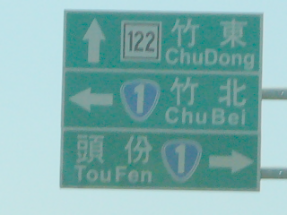

Log Gamma + Bilateral

Image 5：

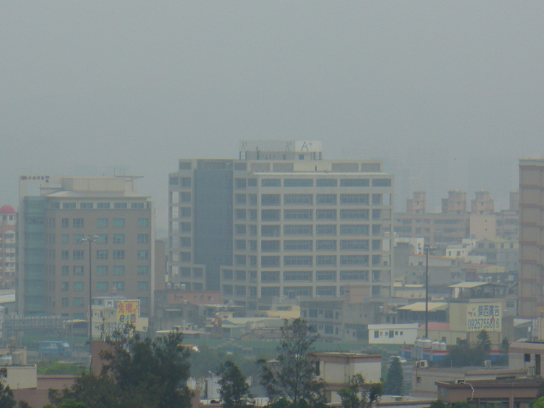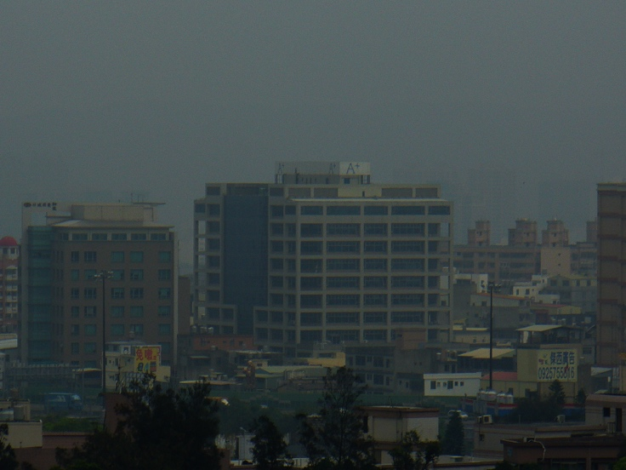

Origin Gamma = 1/2.2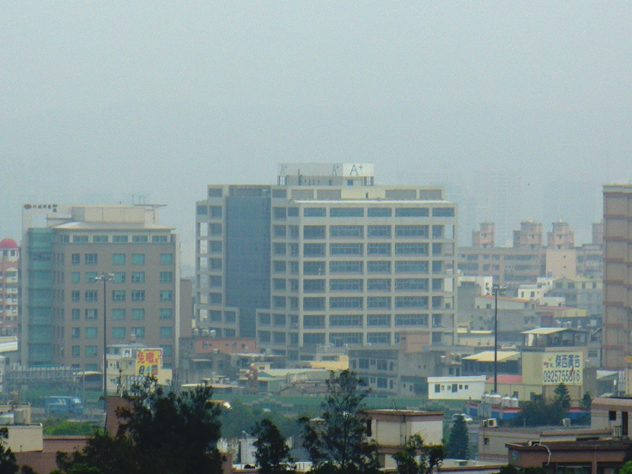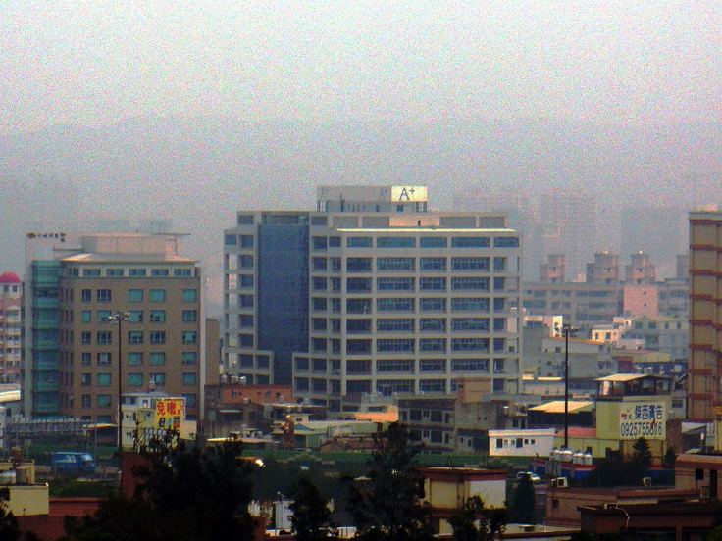

Piecewise-Linear Histogram Equalization

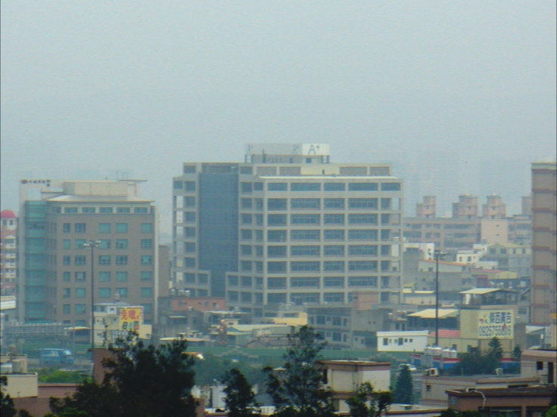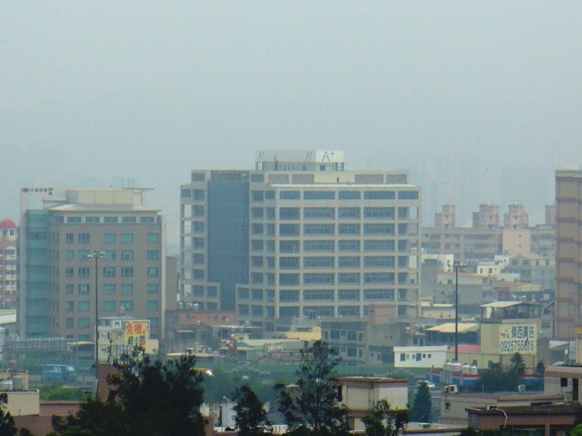

Piecewise + Alpha-Trimmed-Mean. Piecewise + Bilateral

Image 6：

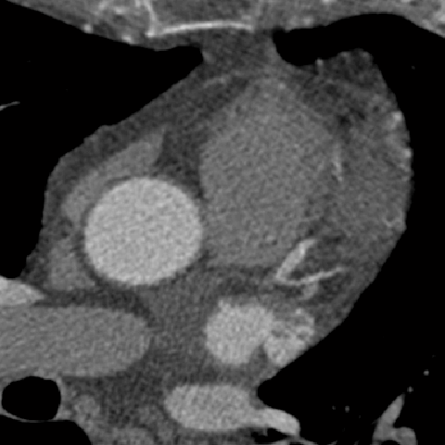 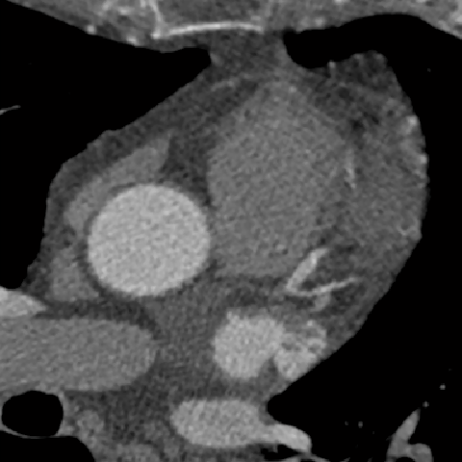

Origin Bilateral

* Discussions：

1. 各張影像處理：

1-1.

圖一高曝光，對比低，Log & Histogram會整個變超白，用Gamma剛剛好，而mean & median圖片會糊糊的，用Bilateral比較不會糊。

1-2.

圖二低曝光，對比低，Gamma會變很黑，Log可以變亮但對比低，Histogram則剛好可以  
高對比，而Mean系列都會糊糊的，因此還是選擇Bilateral。

1-3.

圖三有點像圖二的情況，因此選擇Histogram + Bilateral。

1-4.

圖四希望可以將文字突出且背景不要那麼暗，因此選擇Gamma + Bilateral，其他的Filter文字都會有點糊糊的。

1-5.

圖五清晰的照片但亮度偏暗，經過嘗試發現Histogram表現不錯但看起來不是那麼舒服，因此選擇Piecewise，由於Mean系列都會讓樓頂的A+糊掉，因此選擇Bilateral

1-6.

圖六題目限定Bilateral

2. 程式：

2-1.

在所有的Filter都是用3x3的window去實作，如果上升到5x5整個效率差很多。

2-2.

在實作方面發現Filter的效率都很差，去除python本身比較慢，Bilateral的執行效率最差，網路查詢後發現有人利用積分影像來加速Bilateral。

2-3.

沒有花時間去做指令化跑指定的影像處理的Function，因此都是在原程式碼一個一個加入需要的Function

* Code：

intensity_transform.py

import numpy as np

def ConstrastAdjust(dst, contrast, brightness):

a = contrast

b = brightness

dst = dst * a + b

dst[dst > 255] = 255

dst[dst < 0] = 0

return dst

def GammaCorrection(dst, gamma):

dst = (dst / 255) ** (1 / gamma)

dst = dst * 255

dst[dst > 255] = 255

dst[dst < 0] = 0

return dst

def LogTransform(dst):

c = 255/(np.log(1 + np.max(dst)))

dst = c * np.log(1 + dst)

return dst

def pixelVal(dst, r1, s1, r2, s2):

if (0 <= dst and dst <= r1):

return (s1 / r1)*dst

elif (r1 < dst and dst <= r2):

return ((s2 - s1)/(r2 - r1)) * (dst - r1) + s1

else:

return ((255 - s2)/(255 - r2)) * (dst - r2) + s2

def HistogramEqual(dst, row, col):

R = dst[:,:,0]

G = dst[:,:,1]

B = dst[:,:,2]

R_cdf = np.zeros((256,))

R_sum = 0

G_cdf = np.zeros((256,))

G_sum = 0

B_cdf = np.zeros((256,))

B_sum = 0

for i in range(256):

R_count = np.count_nonzero(R == i)

if R_count != 0:

R_sum = R_sum + R_count

R_cdf[i] = R_sum

G_count = np.count_nonzero(G == i)

if G_count != 0:

G_sum = G_sum + G_count

G_cdf[i] = G_sum

B_count = np.count_nonzero(B == i)

if B_count != 0:

B_sum = B_sum + B_count

B_cdf[i] = B_sum

R_eq = R_cdf / 480000 * 255

G_eq = G_cdf / 480000 * 255

B_eq = B_cdf / 480000 * 255

for i in range(row):

for j in range(col):

R_color, G_color, B_color = dst[i][j]

dst[i][j] = [R_eq[R_color], G_eq[G_color], B_eq[B_color]]

return dst

noise_reduction.py

import numpy as np

def GetMeanFilter():

filter = np.zeros((3, 3))

filter = filter + 1

filter = filter / filter.sum()

return filter

def GetGaussianFilter(sigma):

x, y = np.mgrid[-1:2, -1:2]

gaussion_filter = np.exp(-(x**2 + y**2) / 2 * pow(sigma, 2))

gaussion_filter = gaussion_filter / gaussion_filter.sum() # normalize

return gaussion_filter

def Convolution(dst, row, col, img_extend, filter):

filter_row, filter_col = filter.shape

RGB = np.array([0, 0, 0])

for m in range(row):

for n in range(col):

for i in range(filter_row):

for j in range(filter_col):

RGB = RGB + filter[i][j] * img_extend[i + m][j + n]

dst[m][n] = RGB

RGB = np.array([0, 0, 0])

return dst

def GetMedianFilter(dst, row, col, img_extend):

for i in range(row):

for j in range(col):

tmp = img_extend[i:i+3, j:j+3]

tmp = tmp.reshape(9, 3)

median = np.median(tmp, axis=0)

dst[i][j] = median

return dst

def GetAlphaTrimmedMeanFilter(dst, row, col, img_extend, d):

d2 = int(d/2)

for i in range(row):

for j in range(col):

tmp = img_extend[i:i+3, j:j+3]

tmp = tmp.reshape(9, 3)

tmp = tmp[d2:9-d2, 0:3]

mean = np.mean(tmp, axis=0)

dst[i][j] = mean

return dst

bilateral_filter.py

import numpy as np

def distance(x, y, i, j):

return np.sqrt(((x-i)**2 + (y-j)**2))

def gaussian(x, sigma):

return np.exp(- (x ** 2) / (2 * sigma ** 2))

def BilateralFilter(dst, row, col, img_extend, sigma_d=10, sigma_r=10):

for x in range(row):

for y in range(col):

pixel_filter = np.zeros((3,))

w_sum = np.zeros((3,))

for i in range(x, x+3):

for j in range(y, y+3):

d = distance(i, j, x+1, y+1)

Id = img_extend[i][j] - img_extend[x+1][y+1]

space_w = gaussian(d, sigma_d)

color_w = gaussian(Id, sigma_r)

w = space_w * color_w

pixel_filter += img_extend[i][j] * w

w_sum += w

pixel_filter = pixel_filter / w_sum

dst[x][y] = pixel_filter

return dst

hw01.py

import numpy as np

import sys

import cv2

from intensity_transform import *

from noise_reduction import *

from bilateral_filter import *

path = sys.argv[1]

img = cv2.imread(path)

row, col, channel = img.shape

dst = img.copy()

# dst = ConstrastAdjust(dst, 0.5, 50)

dst = GammaCorrection(dst, 2.2)

# dst = LogTransform(dst)

# pixelVal_vec = np.vectorize(pixelVal)

# dst = pixelVal_vec(dst, 70, 30, 180, 230)

# dst = HistogramEqual(dst, row, col)

dst_extend = np.zeros((row + 2, col + 2, channel))

for i in range(1, row + 1):

for j in range(1, col + 1):

dst_extend[i][j] = dst[i-1][j-1]

# mean_filter = GetMeanFilter()

# dst = Convolution(dst, row, col, dst_extend, mean_filter)

# dst = GetMedianFilter(dst, row, col, dst_extend)

# dst = GetAlphaTrimmedMeanFilter(dst, row, col, dst_extend, 6)

# dst = BilateralFilter(dst, row, col, dst_extend, 1, 5)

dst = np.round(dst)

dst = dst.astype(np.uint8)

cv2.imshow('img', img)

cv2.imshow('dst', dst)

cv2.waitKey(0)

cv2.imwrite("images/test.png", dst)

cv2.destroyAllWindows()